ATACseq Analysis  
Kfir Inbal, Bioinformatician, Madi Lab

Step 1 – QC, Alignment & Peak Calling (Shell Environment)

The original ".bam" files were first converted into FASTQ format for quality analysis using FastQC [1]. The FASTQ files underwent quality refinement with Trimmomatic [2] and Repair.sh from BBMap [3]. The repair script was used to ensure that paired-end reads are correctly matched, removing any mismatches and generating fixed FASTQ files for subsequent analysis. Alignment to the Hg38 reference genome was performed using BWA-MEM [4]. Post-alignment, no duplicates were detected. Mitochondrial chromosomes and blacklist regions were removed to reduce noise and bias, and read coordinates were shifted to account for Tn5 transposase insertion using alignment sieve [5]. Peak calling was performed with MACS2 [6], and footprinting analysis was conducted using TOBIAS [7].

Step 2 – Metadata

A metadata file, Sample_Sheet_All.csv, was created to categorize the samples into four groups: CD4_Good, CD4_Poor, CD8_Good, and CD8_Poor, based on the general metadata from the experiment (2024-04-26 Sample info ATAC.xlsx). This categorization was necessary for the subsequent differential analysis and comparisons in R.

Step 3 – Data Preparation and Differential Chromatin Accessibility Analysis (R Studio; DiffBind)

Sample metadata sheets for each experiment (Sample_Sheet_CD4.csv and Sample_Sheet_CD8.csv) were created from the aligned and filtered BAM files and MACS2 peak files. These sheets served as inputs for the dba function to compare the Good and Poor groups within each experiment. The analysis included the execution of dba.blacklist, dba.count, and dba.normalize functions, employing TMM normalization. Differential analysis was carried out using dba.contrast to compare Good and Poor groups for both CD4 and CD8 datasets, followed by dba.analyze using the EdgeR method to identify differentially accessible regions (DARs).

Sample correlations were visualized using a heatmap generated by dba.plotHeatmap. Principal component analysis (PCA) was performed with dba.plotPCA, using the parameters DBA_CONDITION and label=DBA_ID. DARs were analyzed with dba.report, focusing on p-values due to the limited number of sites with FDR < 0.01. A threshold of 0.05 was applied for significant DARs, while a threshold of 1 was used for all DARs, regardless of significance. Gene names were assigned to each DAR using GREAT (version 4.0.4) [13, 14], with the species assembly set to Human (GRCh38) and the association rule set to 'Single nearest gene within 1000 kb.'

Volcano plots were created from the comprehensive DARs dataset, defining significant genes as those with p-values < 0.05 and logFC > -log(0.7) or < log(0.7). Genes with -log10(p-value) > 5 were capped at y = 5 on the plot. The top ten most significant genes were annotated on the volcano plot. It is important to note that each dot on the volcano plots represents a differentially accessible regions within a gene, meaning the same gene name may appear multiple times.

Additionally, immune-related gene lists were obtained from the ImmPort [12] database, including genes directly associated with immune system functionality, such as cytokines, interleukins, interferons, chemokines, antimicrobials, antigen processing and presentation, and more. Using these immune-related gene lists, a second volcano plot was generated by subsetting the DARs dataset to include only immune-related genes.

Pathway enrichment analysis was conducted using the fgsea [10] package in R. The gene list comprised all genes identified as DARs. The HALLMARK and KEGG MEDICUS signature gene sets from MSigDB (h.all.v2024.1.Hs.symbols.gmt and c2.cp.kegg_medicus.v2024.1.Hs.symbols.gmt) were used as the pathway database, with parameters set to minSize = 15, maxSize = 1000, and eps = 0. Results were categorized into CD4 and CD8-related pathways, with non-relevant pathways manually excluded. Each pathway subset was sorted by normalized enrichment score (NES), and the top 30 pathways were classified as up-regulated or down-regulated based on NES sign. A point plot was generated to display the top 30 pathways, with point size representing the number of genes within each pathway.

Results

CD4 Experiment – Good vs Poor

Correlation Matrix Plot & PCA Plot:

**B**

**A**

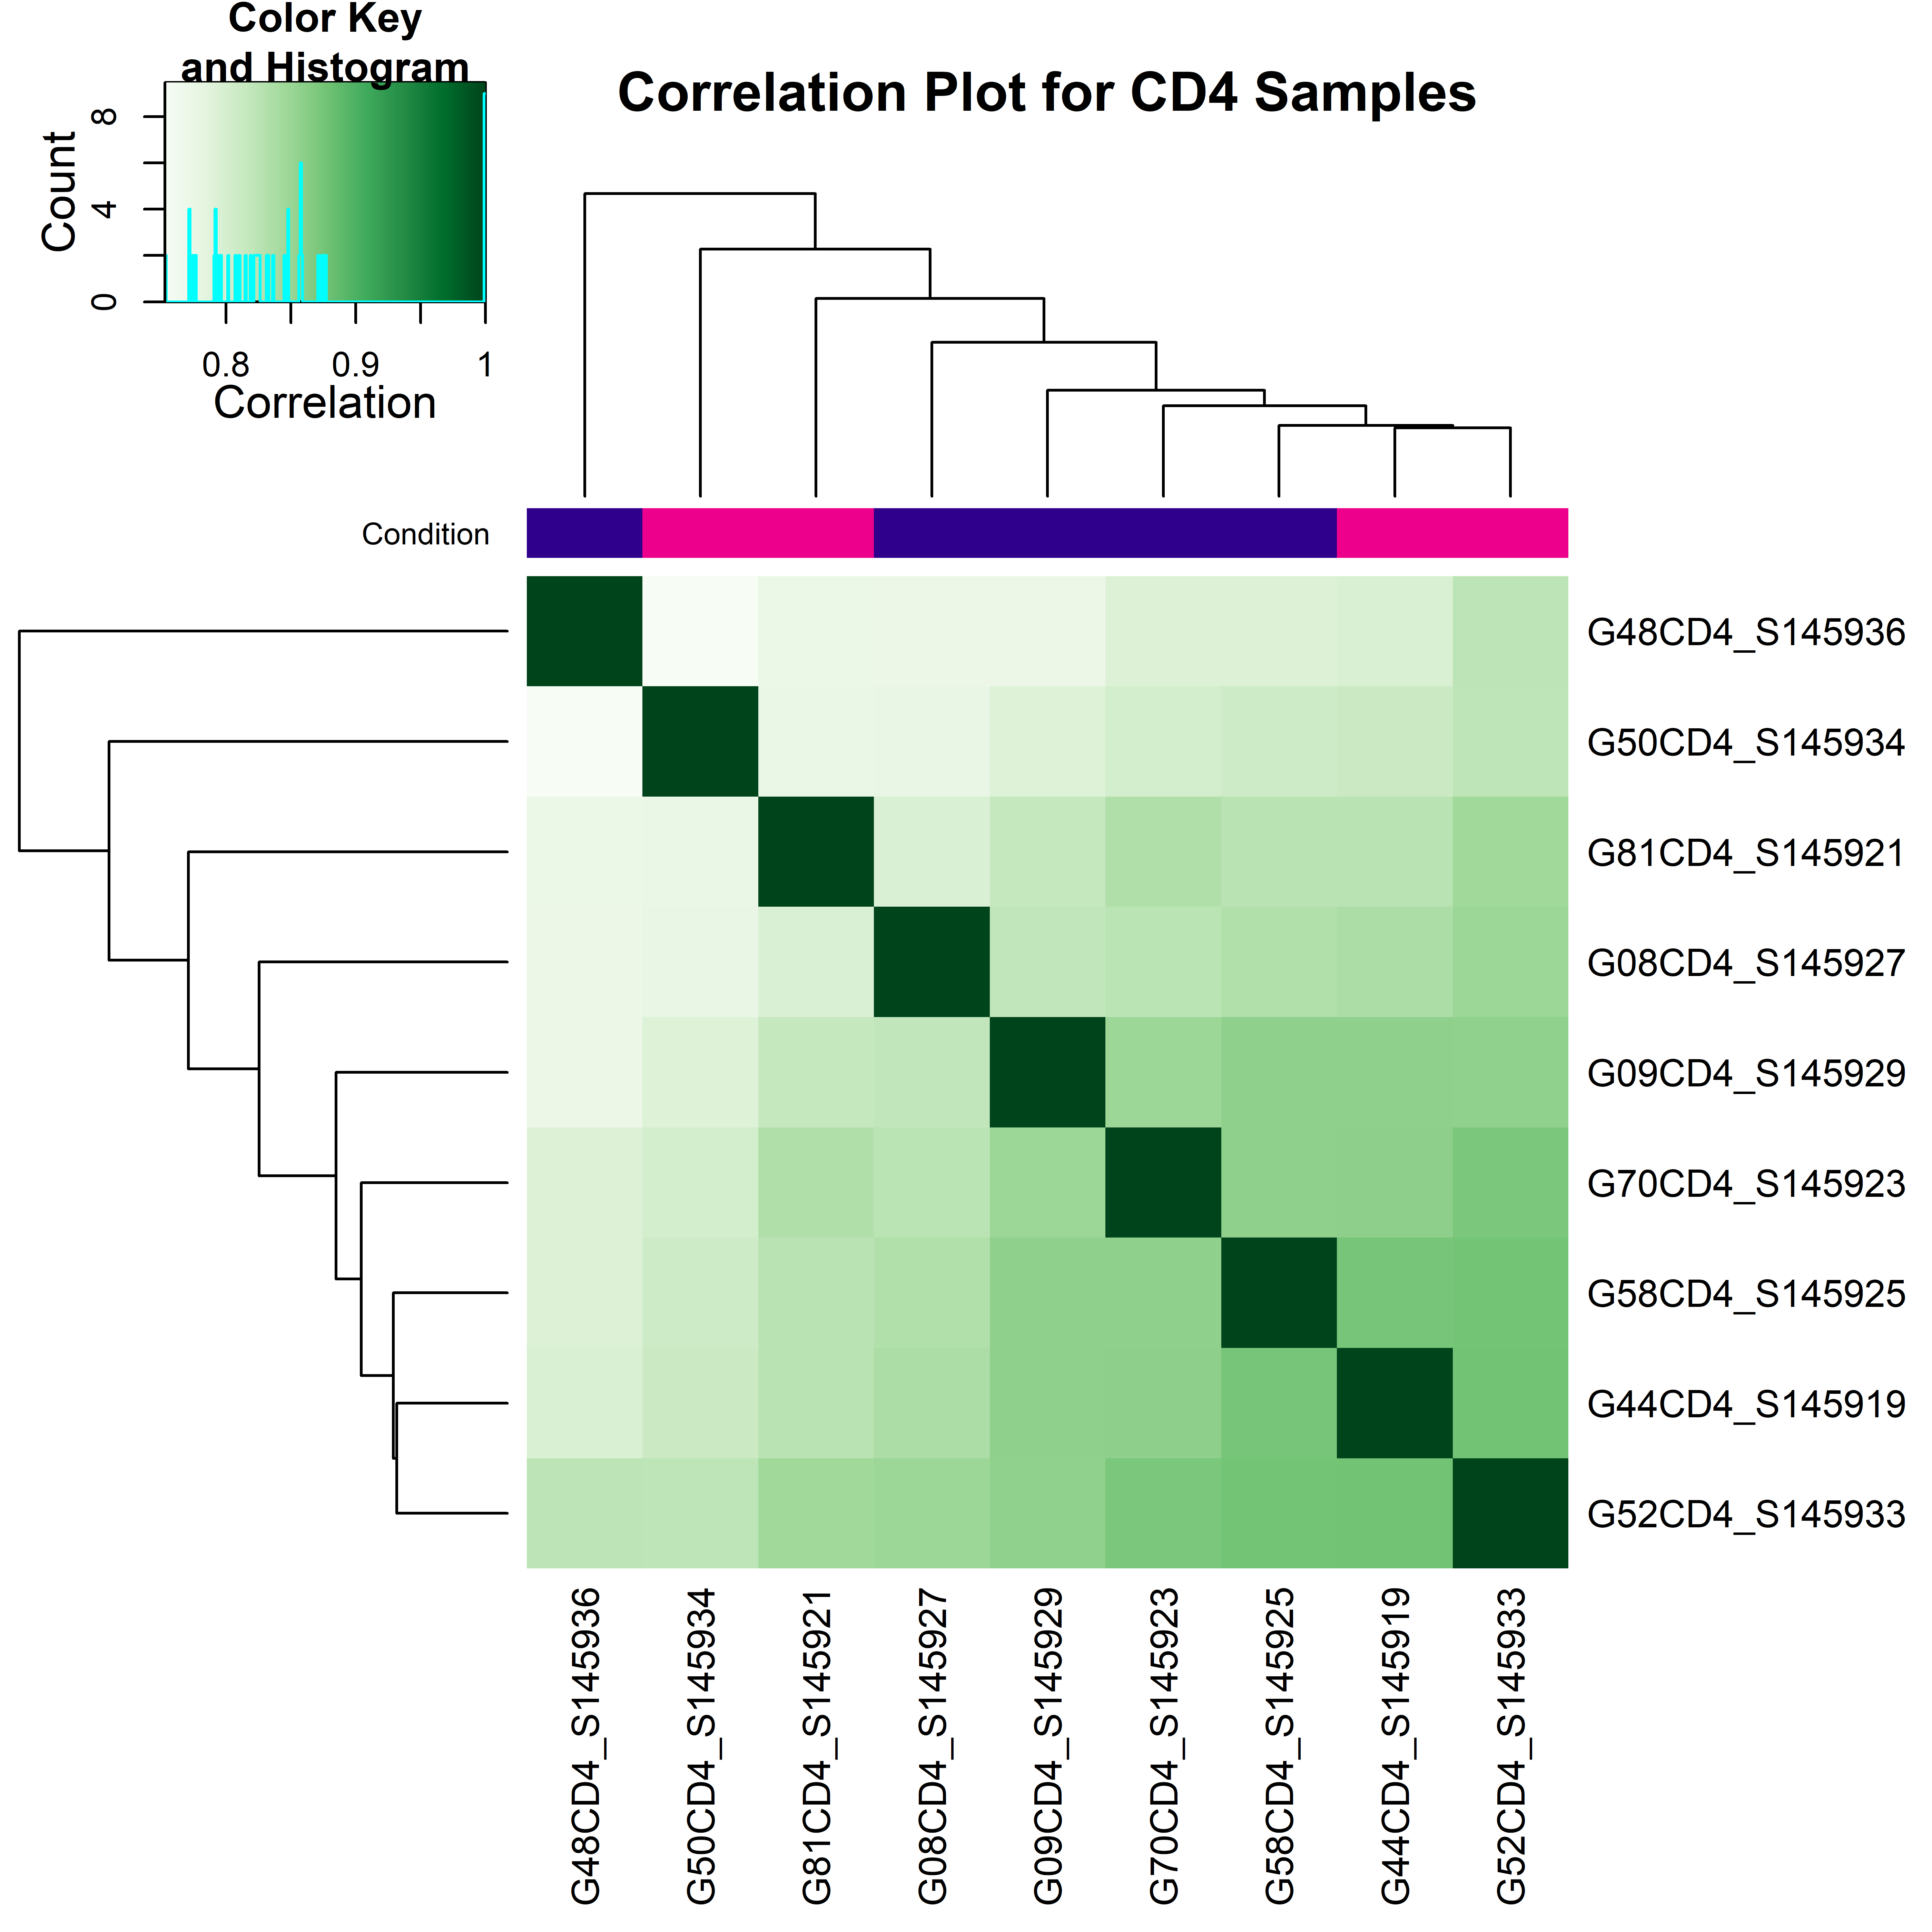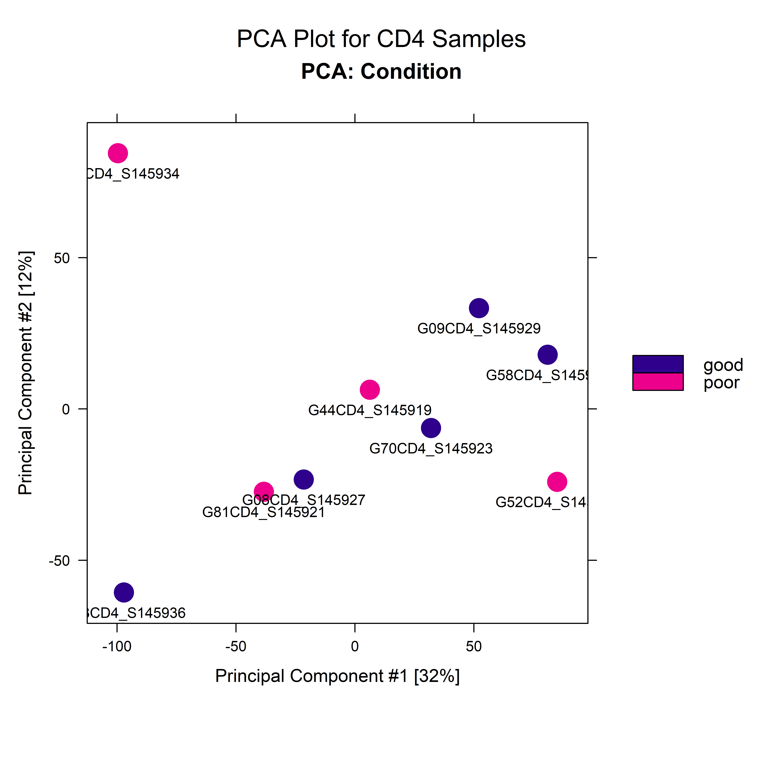

Volcano Plots:

**C**

***Up_In_CD4_Good***

***Up_In_CD4_Poor***



***Up_In_CD4_Good***

***Up_In_CD4_Poor***

GSEA plots:

**D**



Figure Legend:

A – Correlation heatmap of CD4 samples, illustrating the hierarchical clustering of samples based on their Pearson correlation coefficients. These coefficients measure the similarity between chromatin accessibility profiles across different samples, derived from normalized read counts at accessible regions. The color key represents the correlation values, with darker shades of green indicating higher correlations. Conditions are color-coded in the annotation bar above the heatmap: Pink represents Poor responders and Blue represents Good responders.

B – PCA plot of CD4 samples, illustrating the separation of samples based on their chromatin accessibility profiles. Samples are color-coded by condition: Blue represents Good responders and Pink represents Poor responders.

C – Volcano plot of differential chromatin accessibility sites between Good and Poor CD4 samples. Significant regions (p-value < 0.05 and |log2FoldChange| > log2(0.7)) are highlighted in red. The x-axis represents log2 fold change, and the y-axis represents -log10(p-value). Capped values are shown as triangles, and uncapped values as circles. Key upregulated regions are labeled. The first volcano plot includes all DARs, while the second plot displays only immune-related genes derived from ImmPort.

D – Top 20 enriched pathways in the CD4 experiment. Each dot represents a pathway, with dot size reflecting the number of genes involved. The normalized enrichment score (NES) indicates the degree of pathway upregulation/downregulation in relation to chromatin accessibility changes.

CD8 Experiment – Good vs Poor

Correlation Matrix Plot & PCA Plot:

**B**

**A**

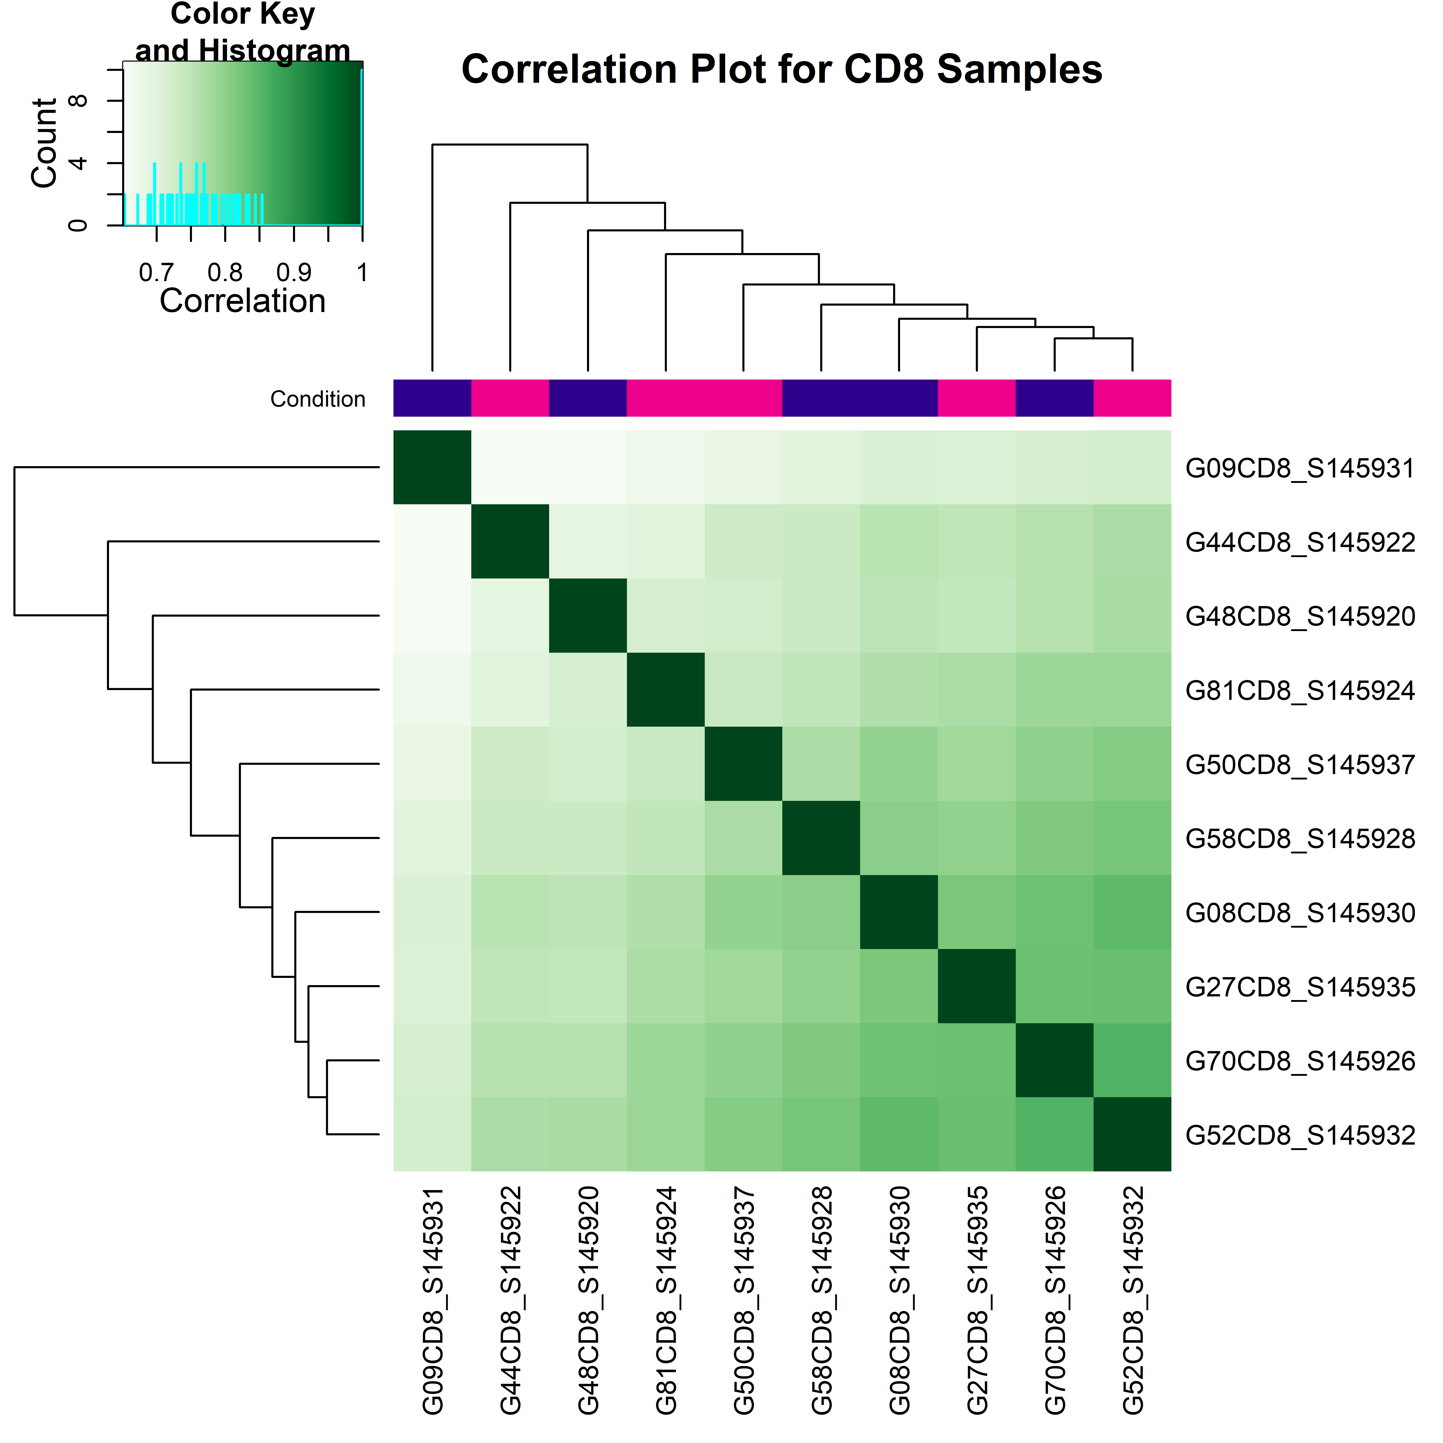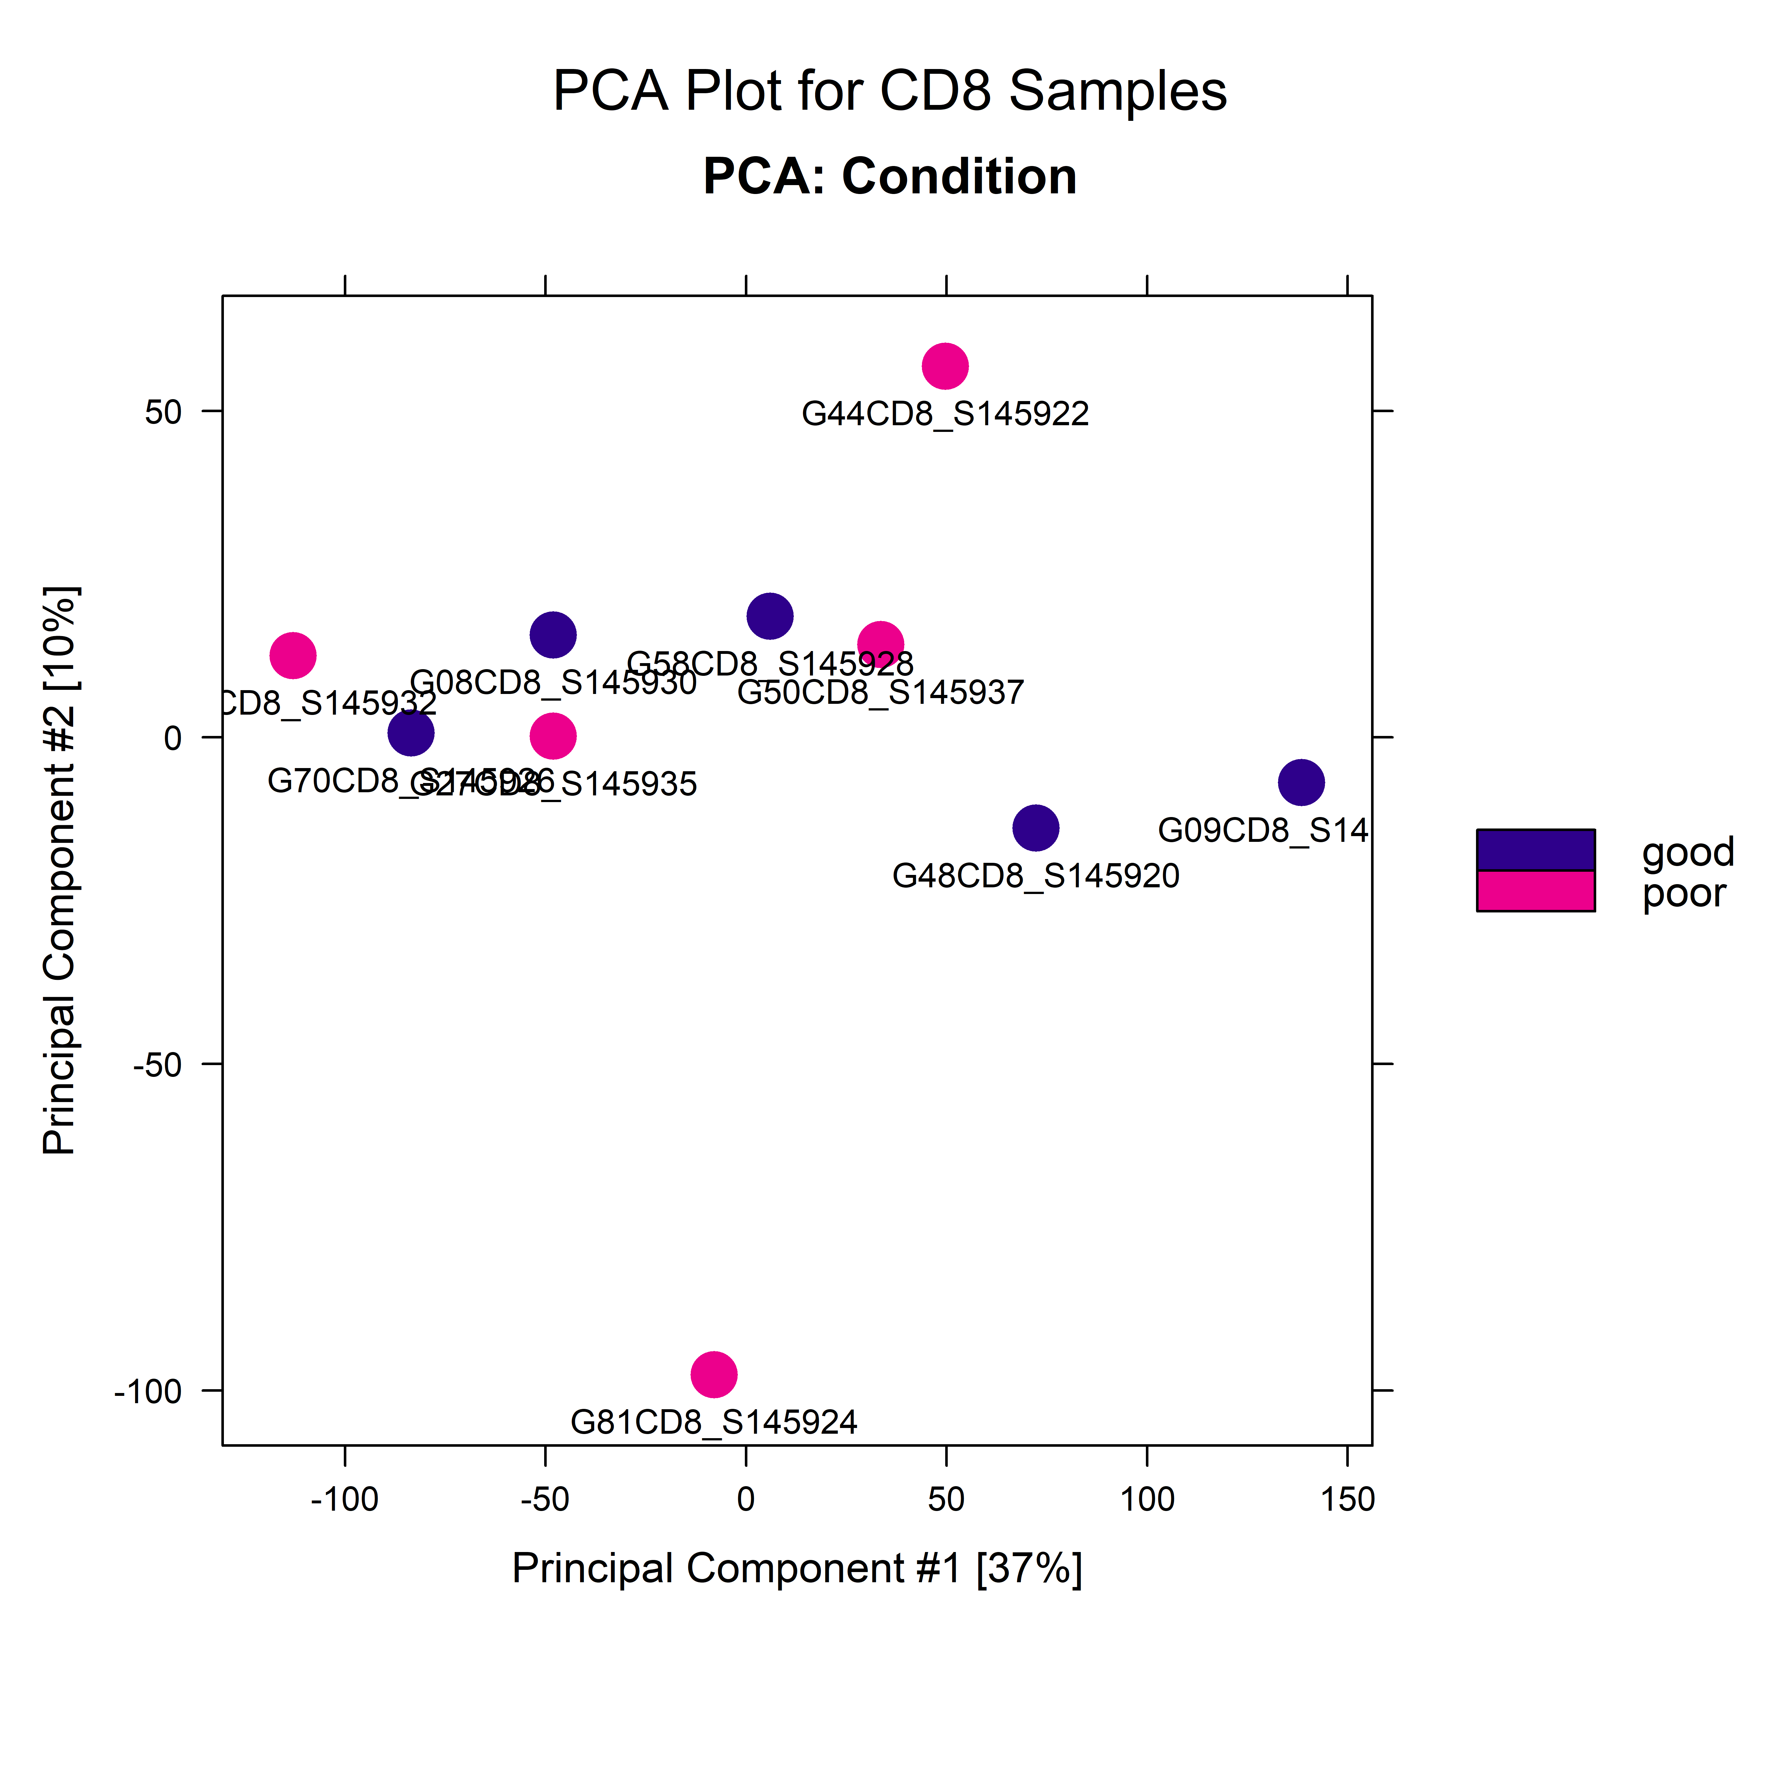

Volcano plots:

**C**

***Up_In_CD8_Good***

***Up_In_CD8_Poor***



***Up_In_CD8_Poor***

***Up_In_CD8_Good***

GSEA plots:

**D**





Figure Legend:

A – Correlation heatmap of CD8 samples, illustrating the hierarchical clustering of samples based on their Pearson correlation coefficients. These coefficients measure the similarity between chromatin accessibility profiles across different samples, derived from normalized read counts at accessible regions. The color key represents the correlation values, with darker shades of green indicating higher correlations. Conditions are color-coded in the annotation bar above the heatmap: Pink represents Poor responders and Blue represents Good responders.

B – PCA plot of CD8 samples, illustrating the separation of samples based on their chromatin accessibility profiles. Samples are color-coded by condition: Blue represents Good responders and Pink represents Poor responders.

C – Volcano plot of differential chromatin accessibility sites between Good and Poor CD8 samples. Significant regions (p-value < 0.05 and |log2FoldChange| > log2(0.7)) are highlighted in red. The x-axis represents log2 fold change, and the y-axis represents -log10(p-value). Capped values are shown as triangles, and uncapped values as circles. Key upregulated regions are labeled. The first volcano plot includes all DARs, while the second plot displays only immune-related genes derived from ImmPort.

D – Top 20 enriched pathways in the CD8 experiment. Each dot represents a pathway, with dot size reflecting the number of genes involved. The normalized enrichment score (NES) indicates the degree of pathway upregulation/downregulation in relation to chromatin accessibility changes.

Summary So Far

Until now, we have conducted open chromatin analysis at the gene level using DiffBind in R, examining differential accessibility between poor and good responders in both CD4 and CD8 cells. Next, using TOBIAS, we will explore differential transcription factor binding sites across these groups, aiming to identify TFs with altered binding patterns in CD4 and CD8 cells.

Step 4 – Bulk Categorization for TOBIAS (Shell Environment)

The aligned and filtered ".bam" files were merged using Samtools [11] because TOBIAS analysis requires a single aggregated BAM file for each experimental group. Since TOBIAS cannot process multiple individual BAM files together for group comparisons, merging ensures that each group (e.g., CD4_Good, CD4_Poor, CD8_Good, CD8_Poor) is represented by one combined BAM file. This aggregation is essential for accurate analysis and comparison, as it consolidates data from multiple samples into a single file per group.

Step 5 – TOBIAS Analysis (Shell Environment)

As mentioned, the aligned and filtered BAM files were organized into groups: CD4 (Good and Poor) and CD8 (Good and Poor). The BAM files for each group were merged into single files to facilitate bulk comparison between Good and Poor categories. TOBIAS functions were then applied: ATACorrect to generate single basepair cutsite tracks, ScoreBigWig to compute continuous footprinting scores across regions, and BINDetect to assess differential binding of transcription factors between the groups. For the BINDetect comparison, peak files from the Good and Poor groups were combined to consolidate the peak data into a single dataset. Additionally, the JASPAR 2024 core non-redundant database of transcription factors [8] was used. Following the BINDetect analysis, a volcano plot was generated to visualize the results, with significant genes defined as those with p-values < 0.05 and logFC > -log(0.95) or < log(0.95).

To strengthen the comparison, we intersected the differentially expressed (DE) transcription factors (TFs) identified from TOBIAS BINDetect results with those from the R DiffBind [9] analysis. TFs that were commonly found in both analyses with the same fold-change direction were filtered based on a threshold of -log(0.7) in the fold change from either DiffBind or TOBIAS BINDetect results. Selected TFs, including POU1F1 (Up_Good), GLIS1 (Up_Poor), POU4F3 (Up_Good), and VEZF1 (Up_Poor), were chosen for the footprinting "aggregate" plot across all sites. This type of plot visualizes the aggregate footprinting signal across a set of genomic regions, such as transcription factor binding sites, providing a summary view of the footprinting data across multiple samples or conditions. Same TFs were also visualized as a heatmap using TOBIAS PlotHeatmap function.

Results

CD4 Good vs Poor

Differential Transcription Factor Binding Volcano Plot

**A**



Aggregated Footprinting Plots And Heatmaps

Footprinting Aggregate Plots

**B**

**CD4 Up_Good:**

POU1F1 –

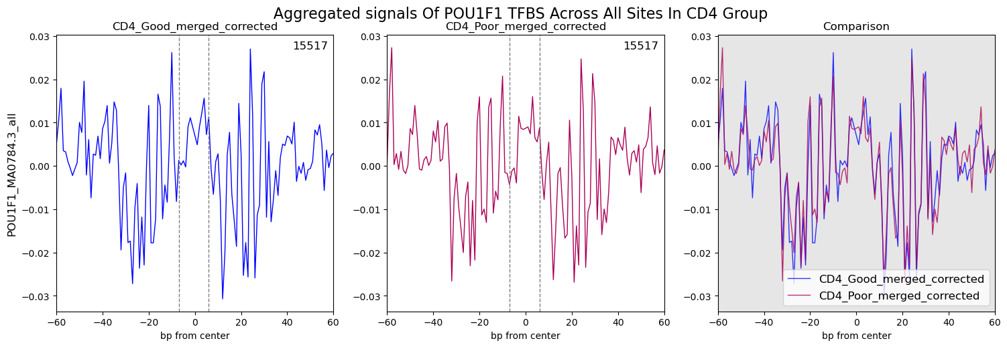

POU4F3 –

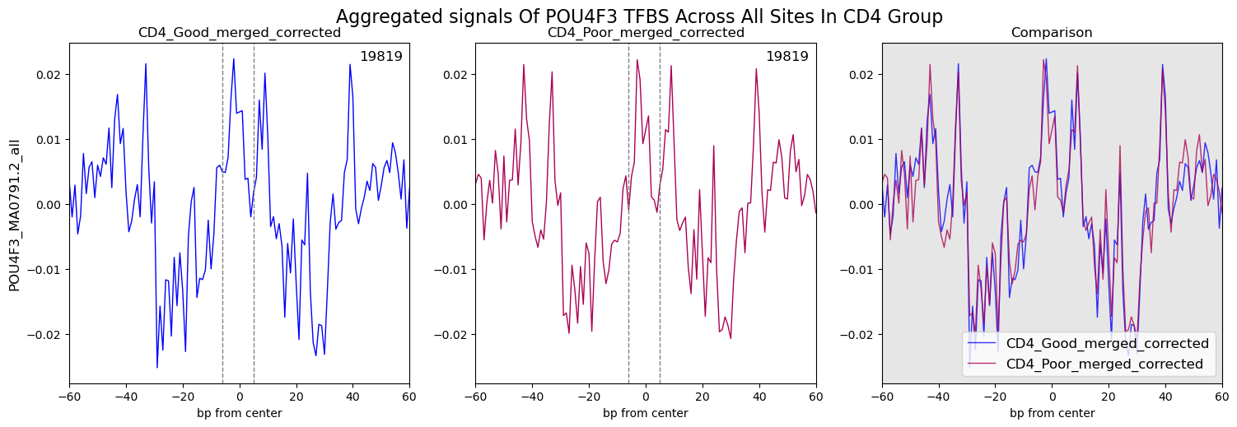

**CD4 Up_Poor:**

GLIS1 –

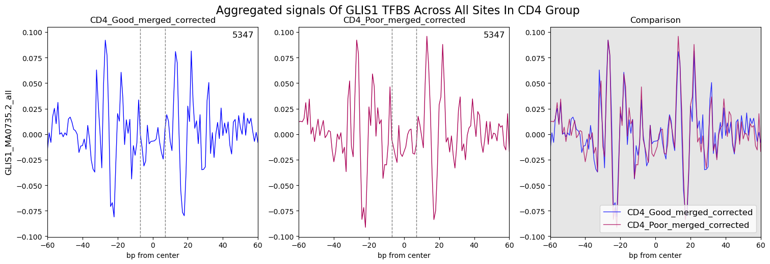

VEZF1 –

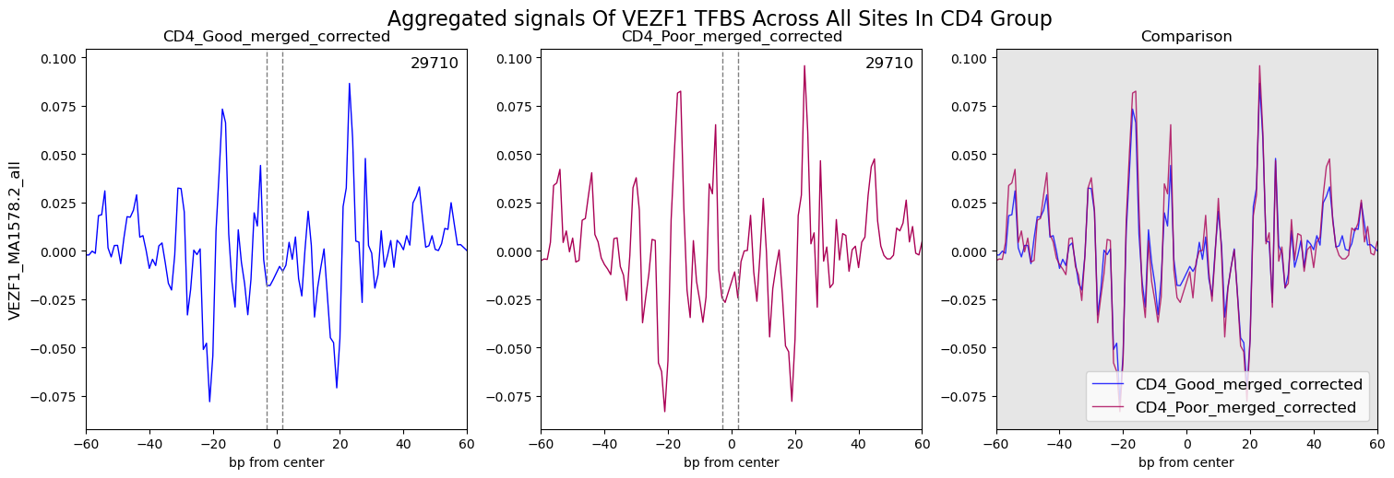

**CD4 Heatmaps**

**C**

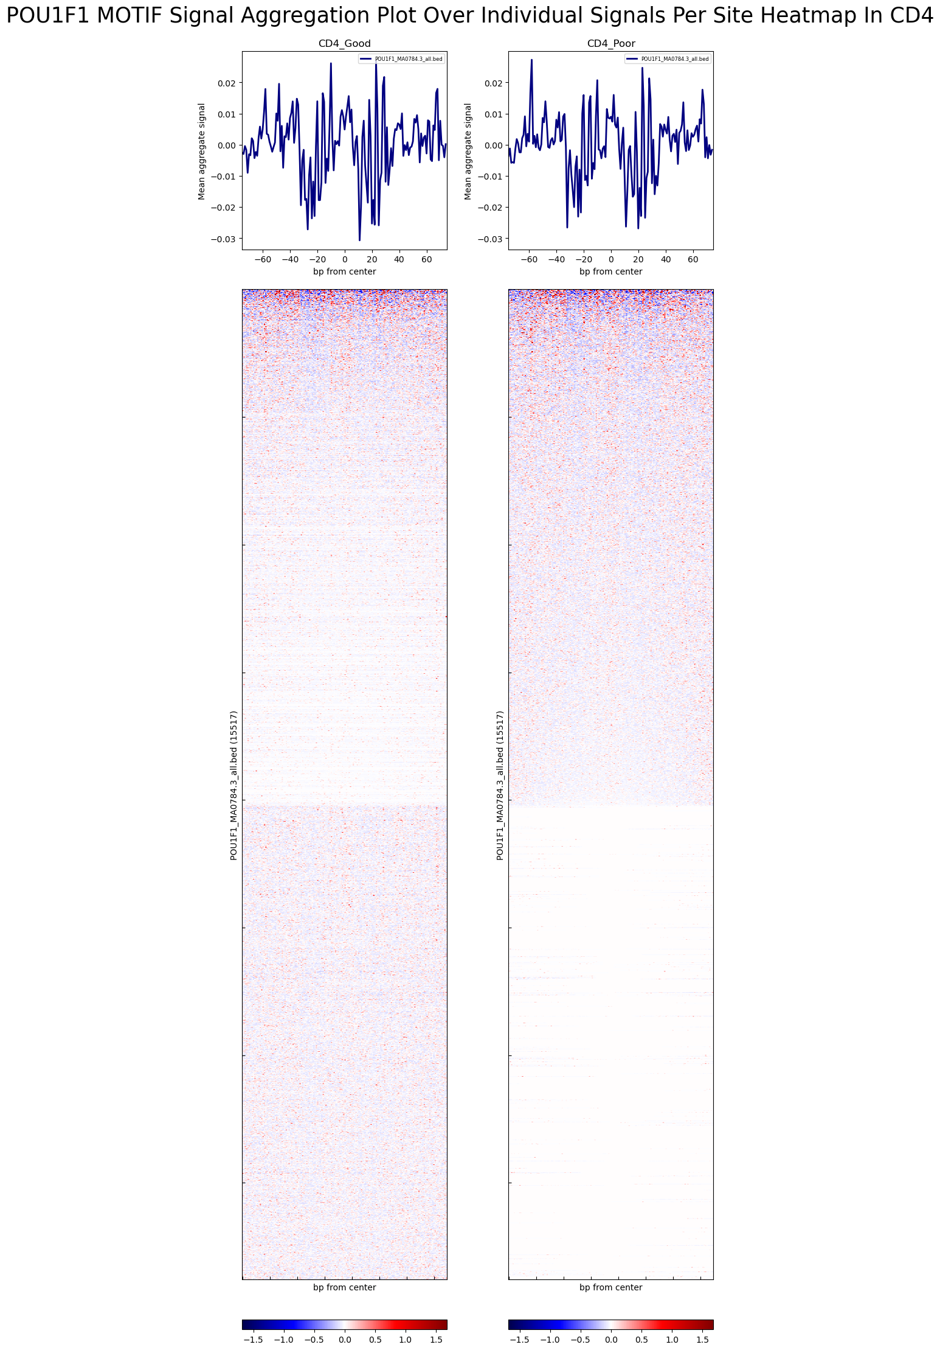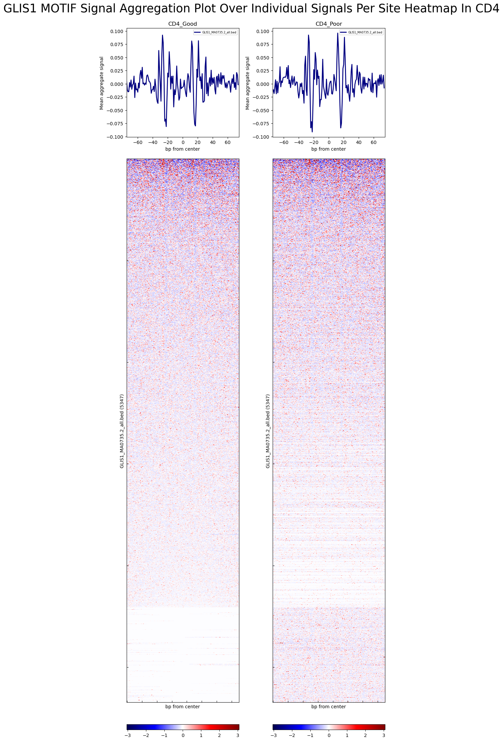

Figure Legend:

A – Volcano plot showing the differential binding of TFs between Good and Poor CD4 groups. The x-axis displays log2 fold change, and the y-axis shows -log10(p-value). Significant TFs (p-value < 0.05 and |log2FoldChange| > log2(0.95)) are highlighted in red/green. Key upregulated TFs are labeled.

B – Comparative footprinting aggregate plots for selected TFs (POU1F1, POU4F3, GLIS1, VEZF1) in CD4_Good (left), CD4_Poor (middle), and their comparison (right). The plot shows aggregated binding intensity across all sites, illustrating changes within the motif and flanking regions. The x-axis represents base pairs from the center, and the y-axis shows the mean footprinting signal. Dashed lines indicate the motif's start and end. The comparison panel overlays the corrected footprints of CD4_Good and CD4_Poor, highlighting differences between the groups.

C – Aggregate plots (above) and heatmaps (below) for TFs (POU1F1, GLIS1) in CD4_Good (left) and CD4_Poor (right). The plot above the heatmap is an aggregate footprinting plot, summarizing the average binding intensity across all sites. The heatmap below visualizes the footprinting signal (binding intensity) for individual binding sites. Each row represents a different binding site, while the x-axis represents the distance in base pairs from the center of each site. The red and blue color scheme indicates relative signal strength, with darker red colors indicating stronger binding intensity, and lighter blue colors suggesting weaker or no binding.

CD8 Good vs Poor

Differential Transcription Factor Binding Volcano Plot

**A**



Aggregated Footprinting Plots And Heatmaps

Footprinting Aggregate Plots

**B**

**CD8_Up_Good:**

POU4F3 –

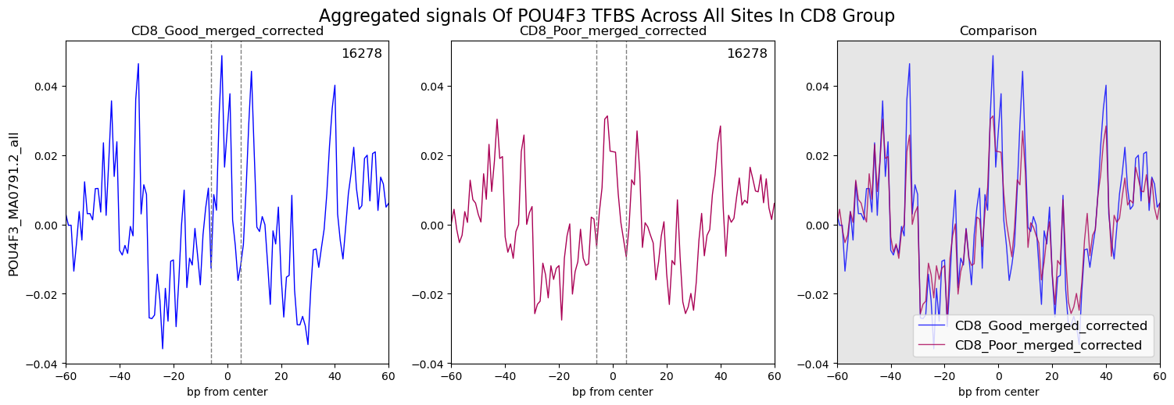

MOEX1 –

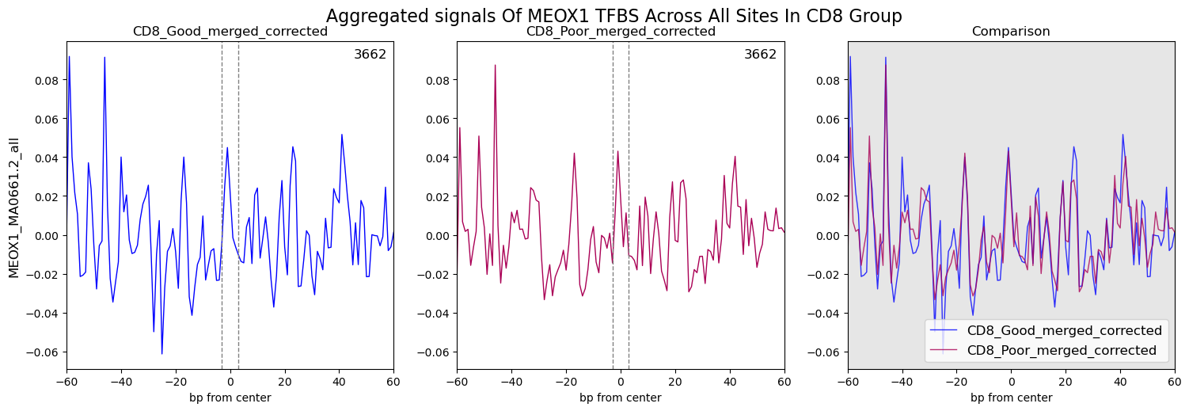

**CD8_Up_Poor:**

VEZF1 – 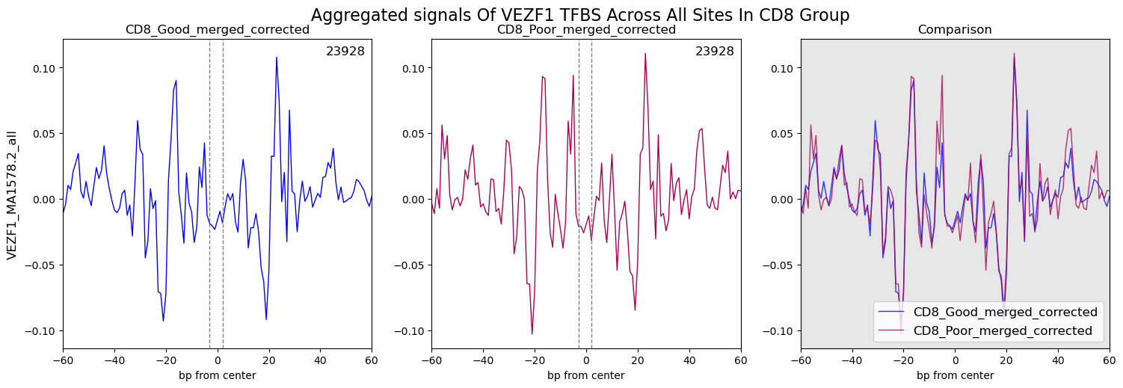

**CD8 Heatmaps**

**C**

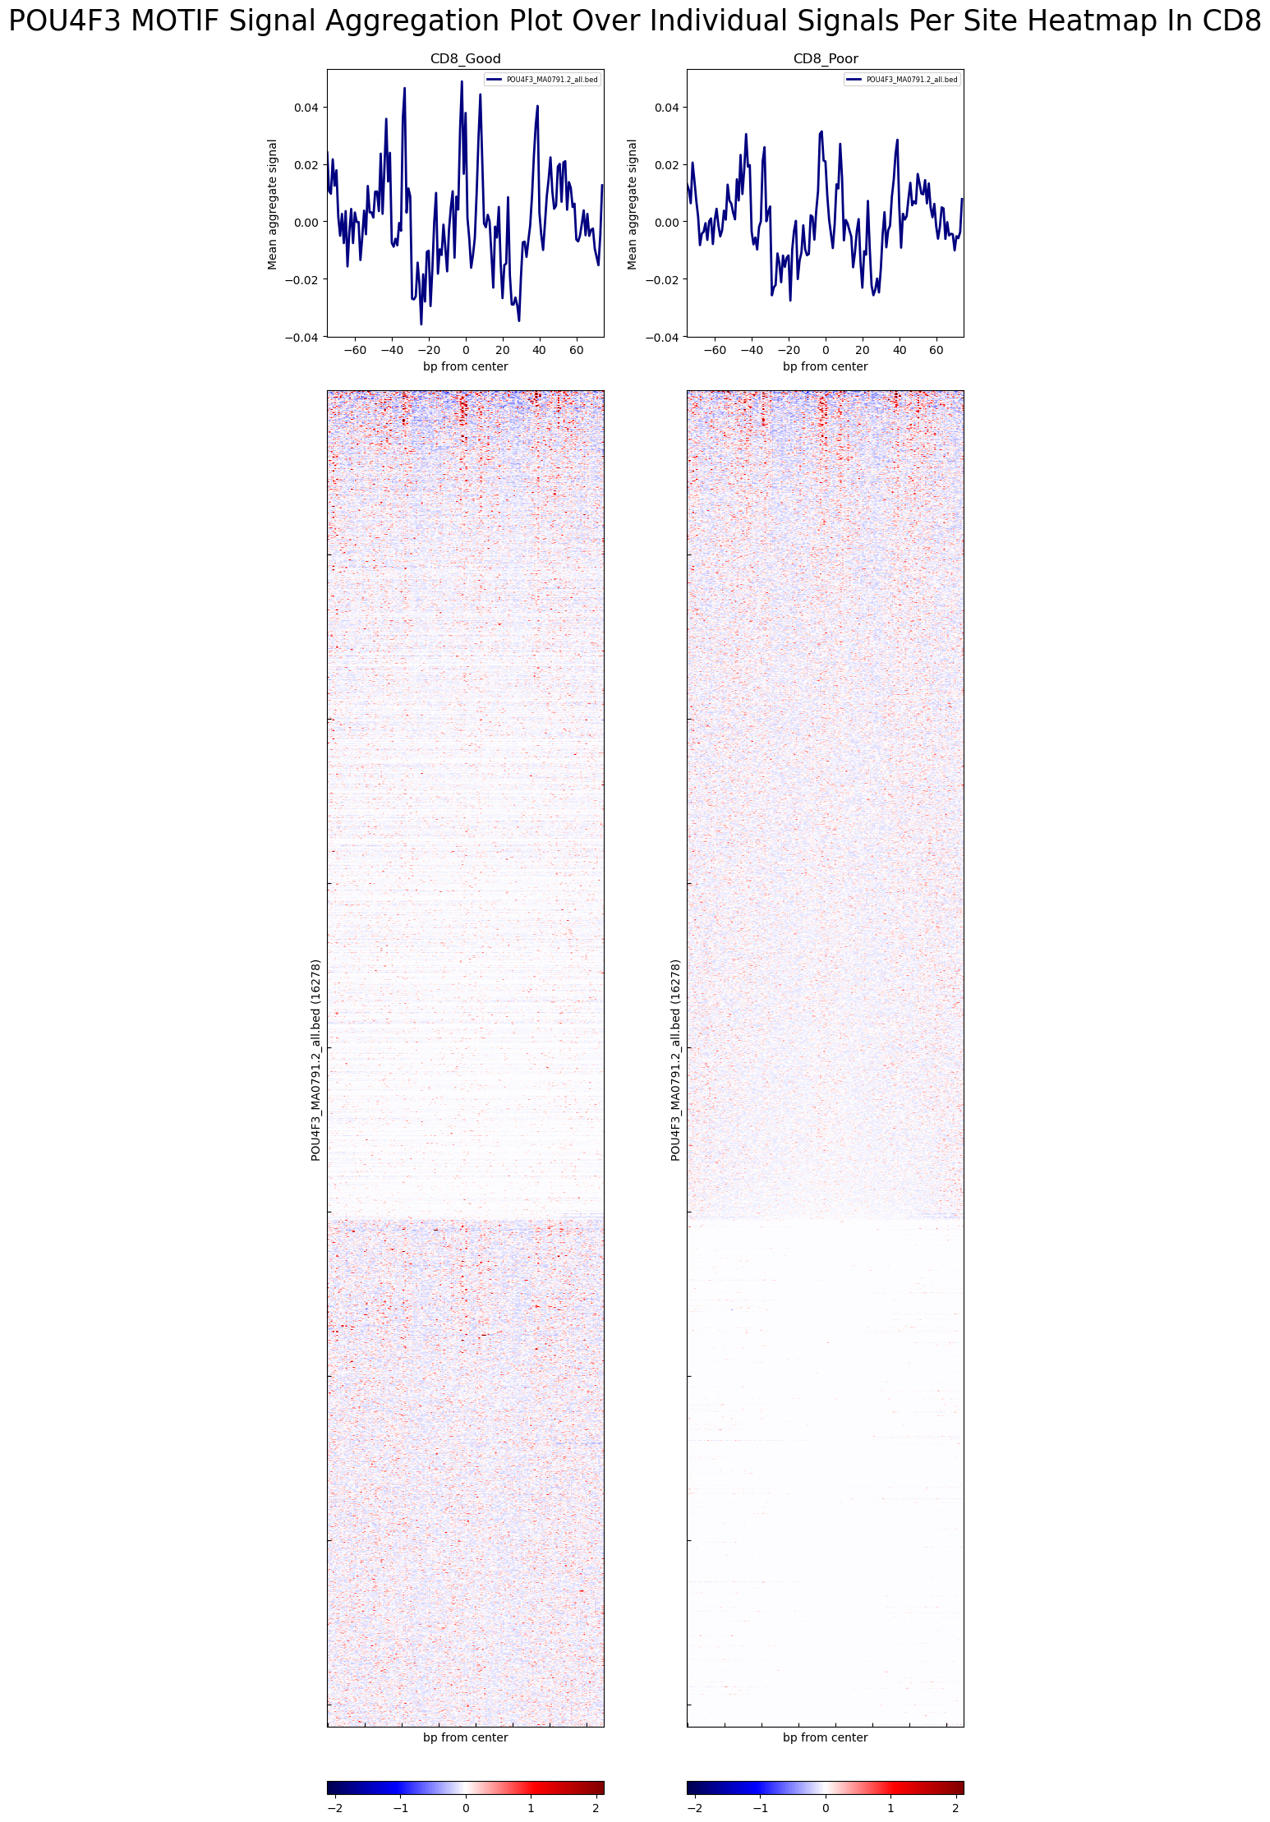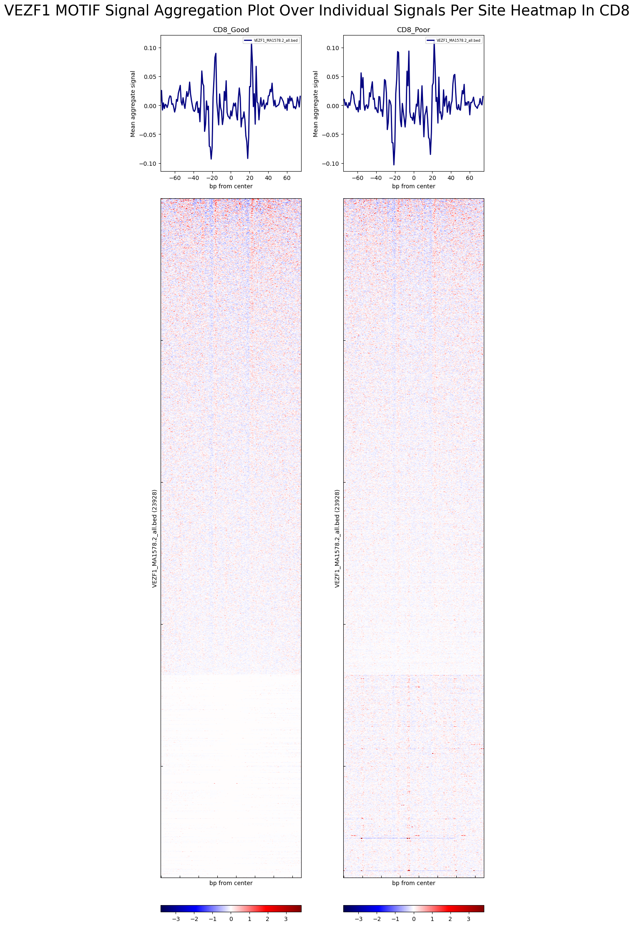

Figure Legend:

A – Volcano plot showing the differential binding of TFs between Good and Poor CD8 groups. The x-axis displays log2 fold change, and the y-axis shows -log10(p-value). Significant TFs (p-value < 0.05 and |log2FoldChange| > log2(0.95)) are highlighted in red/green. Key upregulated TFs are labeled.

B – Comparative footprinting aggregate plots for selected TFs (POU4F3, MOEX1 and VEZF1) in CD8_Good (left), CD8_Poor (middle), and their comparison (right). The plot shows aggregated binding intensity across all sites, illustrating changes within the motif and flanking regions. The x-axis represents base pairs from the center, and the y-axis shows the mean footprinting signal. Dashed lines indicate the motif's start and end. The comparison panel overlays the corrected footprints of CD8_Good and CD8_Poor, highlighting differences between the groups.

C – Aggregate plots (above) and heatmaps (below) for TFs (POU4F3 and VEZF1)) in CD8_Good (left) and CD8_Poor (right). The plot above the heatmap is an aggregate footprinting plot, summarizing the average binding intensity across all sites. The heatmap below visualizes the footprinting signal (binding intensity) for individual binding sites. Each row represents a different binding site, while the x-axis represents the distance in base pairs from the center of each site. The red and blue color scheme indicates relative signal strength, with darker red colors indicating stronger binding intensity, and lighter blue colors suggesting weaker or no binding.

CD4 vs CD8 Results Overlap

To gain deeper insights into the ATAC-seq data, an overlap analysis was performed to identify common differentially accessible regions (DARs) and differentially bound transcription factors (DBTFs) between CD8 and CD4 T cells.

Venn diagrams were generated using the ggvenn package to visualize the overlap of up- and down-regulated DARs and DBTFs between both experiments. This helped highlight DARs and DBTFs that were consistently differentially regulated across both conditions.  
To assess the statistical significance of the overlap of up/down regulated genes in both cell types, a hypergeometric test was performed using the ‘phyper’ function from the ‘stats’ package. The background gene pool (universe) was defined as the union of unique gene names associated with all DARs/DBTFs from both CD4 and CD8 analyses. From this universe, a subset of significant genes was extracted based on thresholds from the volcano plots (DARs analysis: p-value < 0.05 and |logFC| > -log(0.7); DBTFs analysis: p-value < 0.05 and |logFC| > -log(0.95)). Upregulated or downregulated genes were further subsetted from the significant genes.

The hypergeometric test calculated the probability of the observed overlap by comparing the number of shared genes between the two cell types against the expected overlap by chance. The parameters for the ‘phyper’ function were defined as follows:

* **q**: The number of overlapping up/down regulated genes between CD4 and CD8.
* **m**: The number of up/down regulated genes in CD4.
* **n**: the number of background genes that are not up/down regulated in CD4 (i.e., universe size minus ***m***).
* **k**: The number of up/downregulated genes in CD8.

The hypergeometric formula used to calculate the cumulative probability is:

$$P(X≤q)=\sum_{i=0}^{q}{\frac{\left(\begin{aligned}m \\ i\end{aligned}\right)- \left(\begin{aligned}n \\ k-i\end{aligned}\right)}{\left(\begin{aligned}m + n \\ k\end{aligned}\right)}}$$

Where $\left(\begin{aligned}m \\ i\end{aligned}\right)$ represents the binomial coefficient (the number of ways to choose $i$ successes from $m$). This calculation helps determine whether the overlap of genes is significantly higher than expected by chance. To get the p-value for the overlap, the upper tail probability $P(X≥q)$ was calculated using:

$$P(X≥q)=1-phyper(q-1, m,n,k)$$

(q – 1) is set to include the value of q as part of the test.  
  
The statistical significance of the p-value is denoted on the Venn diagram by an asterisk (*), with the following significance levels:

* p ≤ 0.05: *
* p ≤ 0.01: **
* p ≤ 0.001: ***
* p ≤ 0.0001: ****

In addition, heatmaps (generated using the ‘pheatmap’ package) were created to compare the logFC values of common gene names associated with DARs and DBTFs between the two cell types. These heatmaps provided a visual representation of the similarities and differences in the shared associated gene names, facilitating a direct comparison of regulatory changes in CD8 and CD4 cells.

Overlap Results

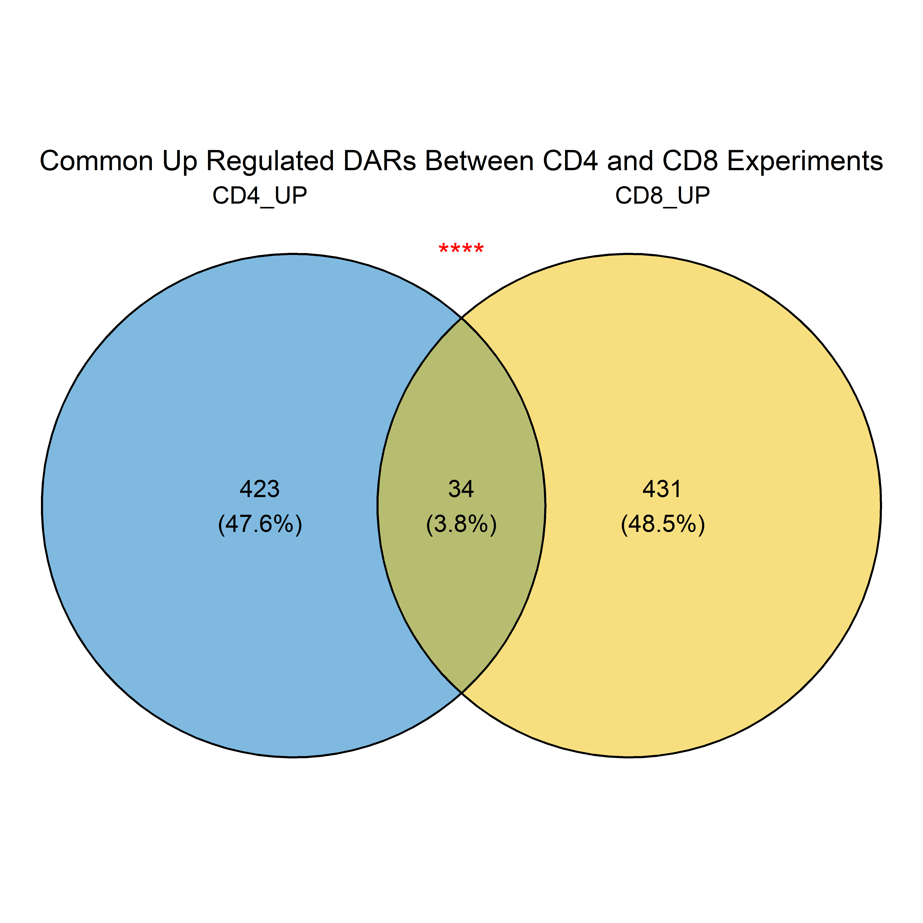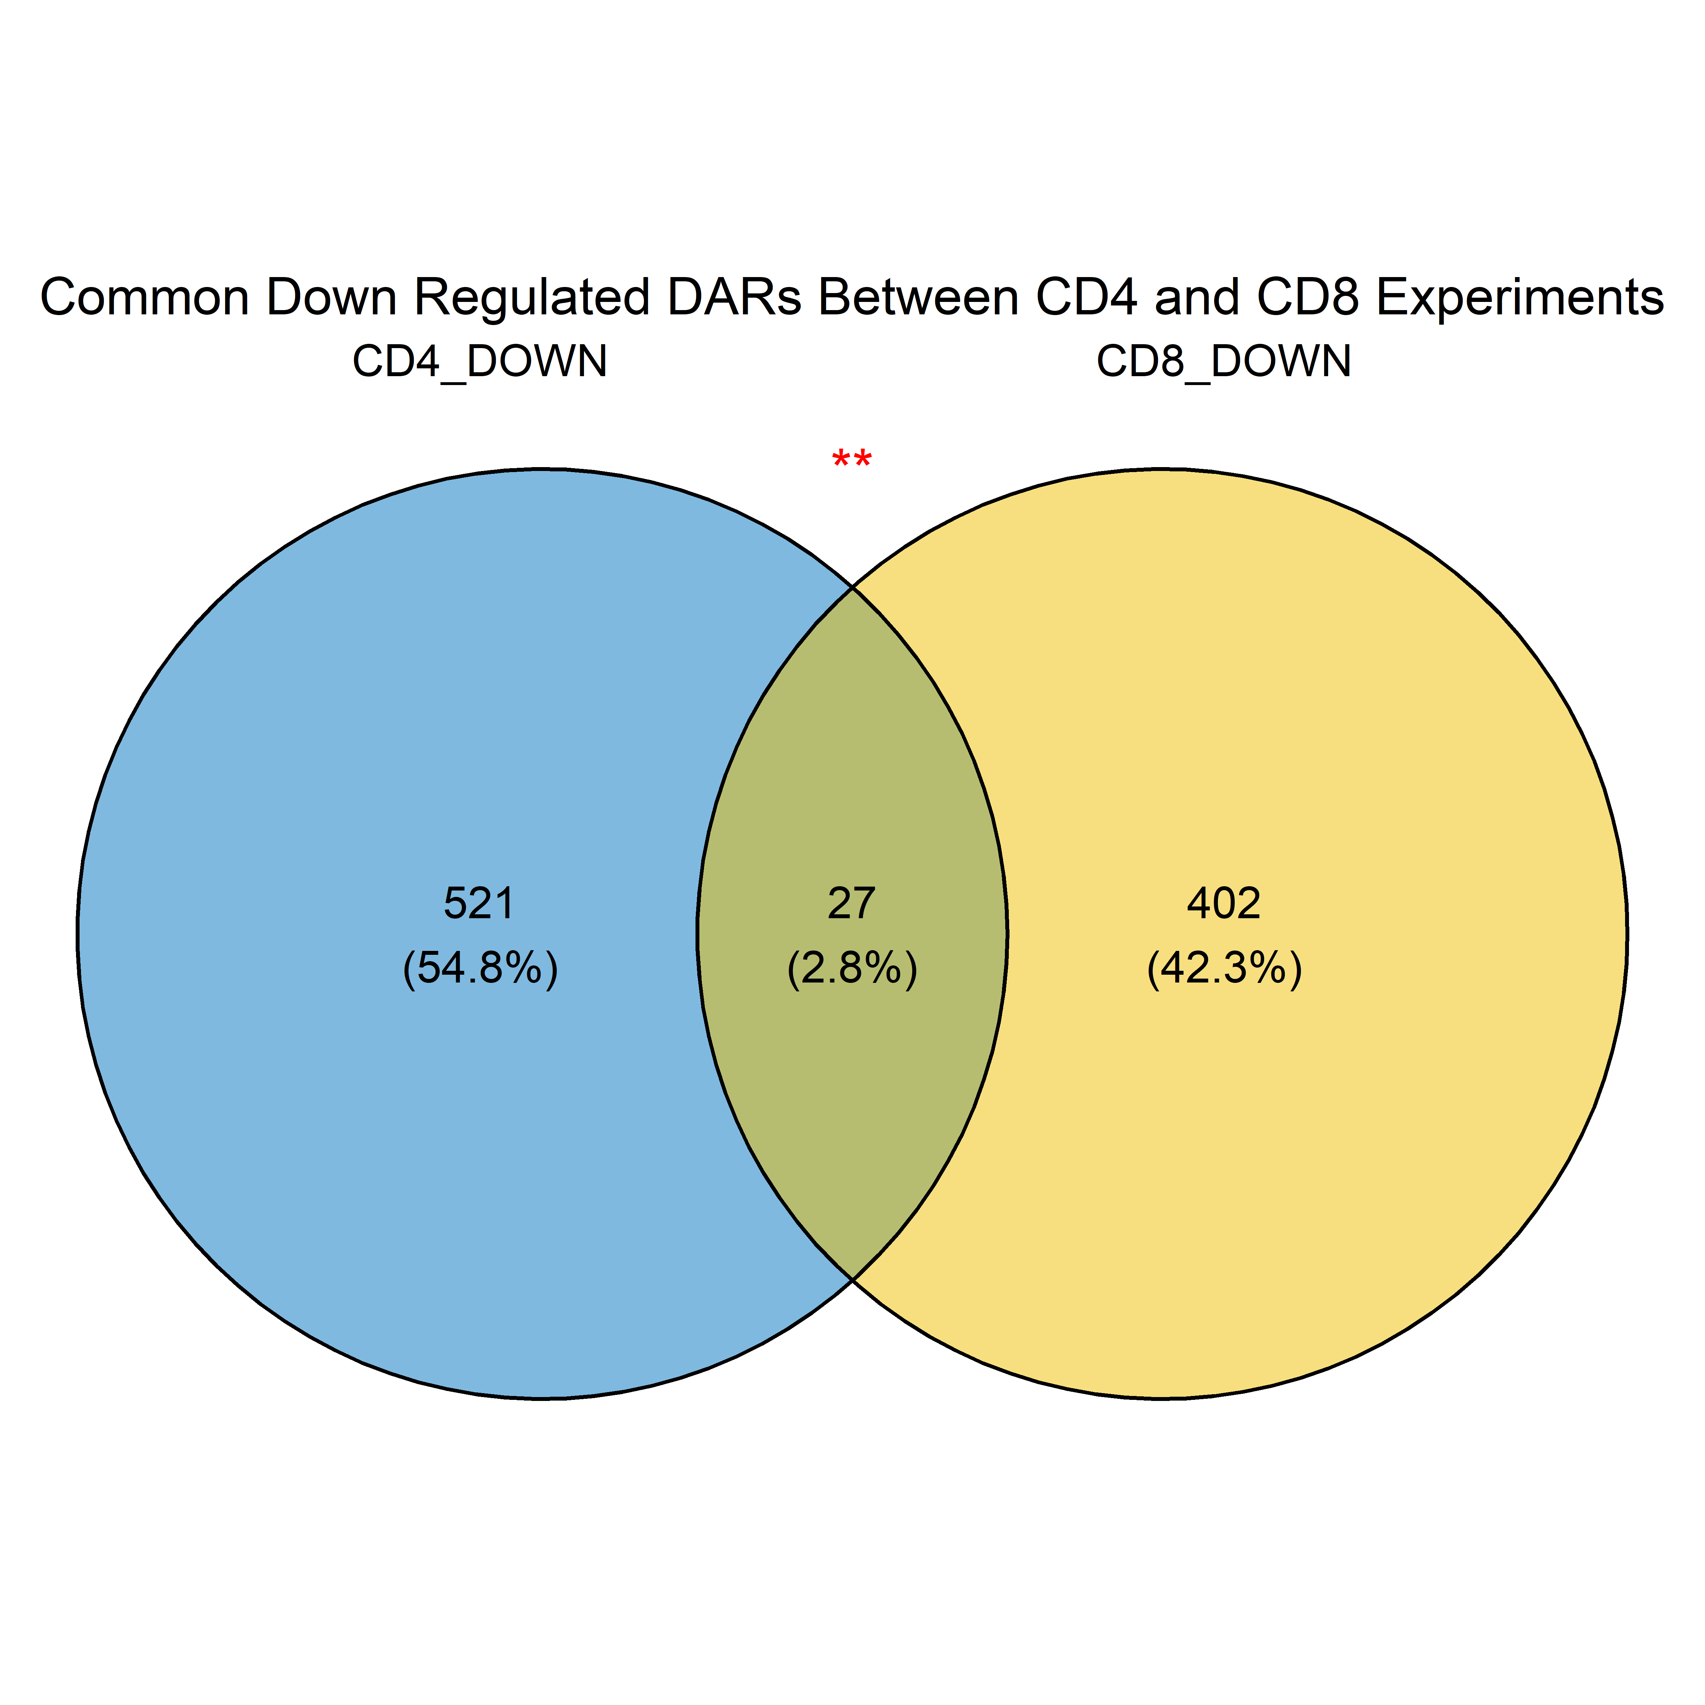Common DARs

**A**

**B**



**C**

Figure Legend:

A – A Venn diagram depicting the number of common up-regulated DARs in the overlap region. Unique up-regulated DARs for CD4 are shown on the left, and unique up-regulated DARs for CD8 are shown on the right. An asterisk (*) indicates the statistical significance of the overlap, calculated using a hypergeometric test, with more asterisks indicating a higher level of significance. The p-value for this overlap is 1.695016e-06.

B – A Venn diagram depicting the number of common down-regulated DARs in the overlap region. Unique down-regulated DARs for CD4 are shown on the left, and unique down-regulated DARs for CD8 are shown on the right. An asterisk (*) indicates the statistical significance of the overlap, calculated using a hypergeometric test, with more asterisks indicating a higher level of significance. The p-value for this overlap is 0.003660285.

C – A heatmap comparing the logFC values of common DARs between CD4 and CD8 experiments. Each row represents a gene associated with DARs. Darker red cells indicate a higher degree of up-regulation, and darker blue cells represent a greater extent of down-regulation of DARs.

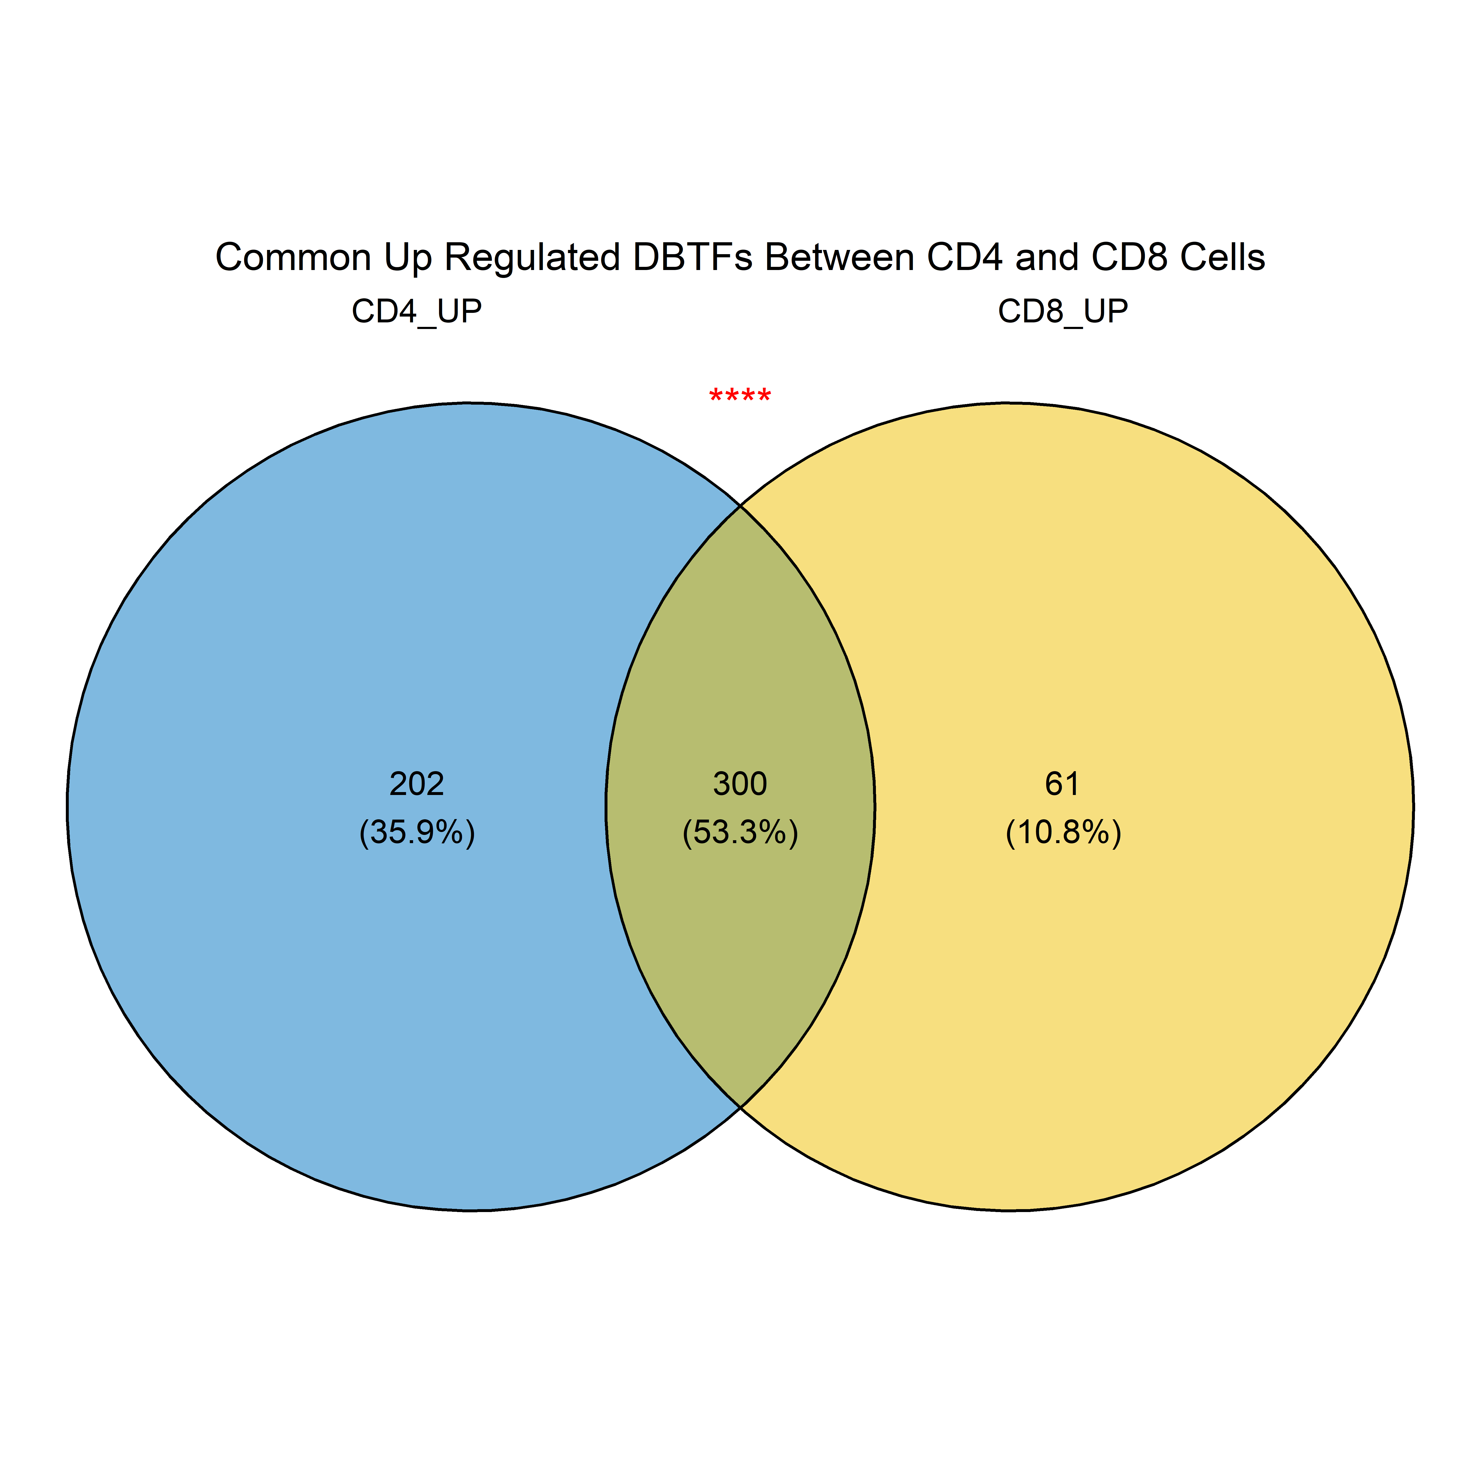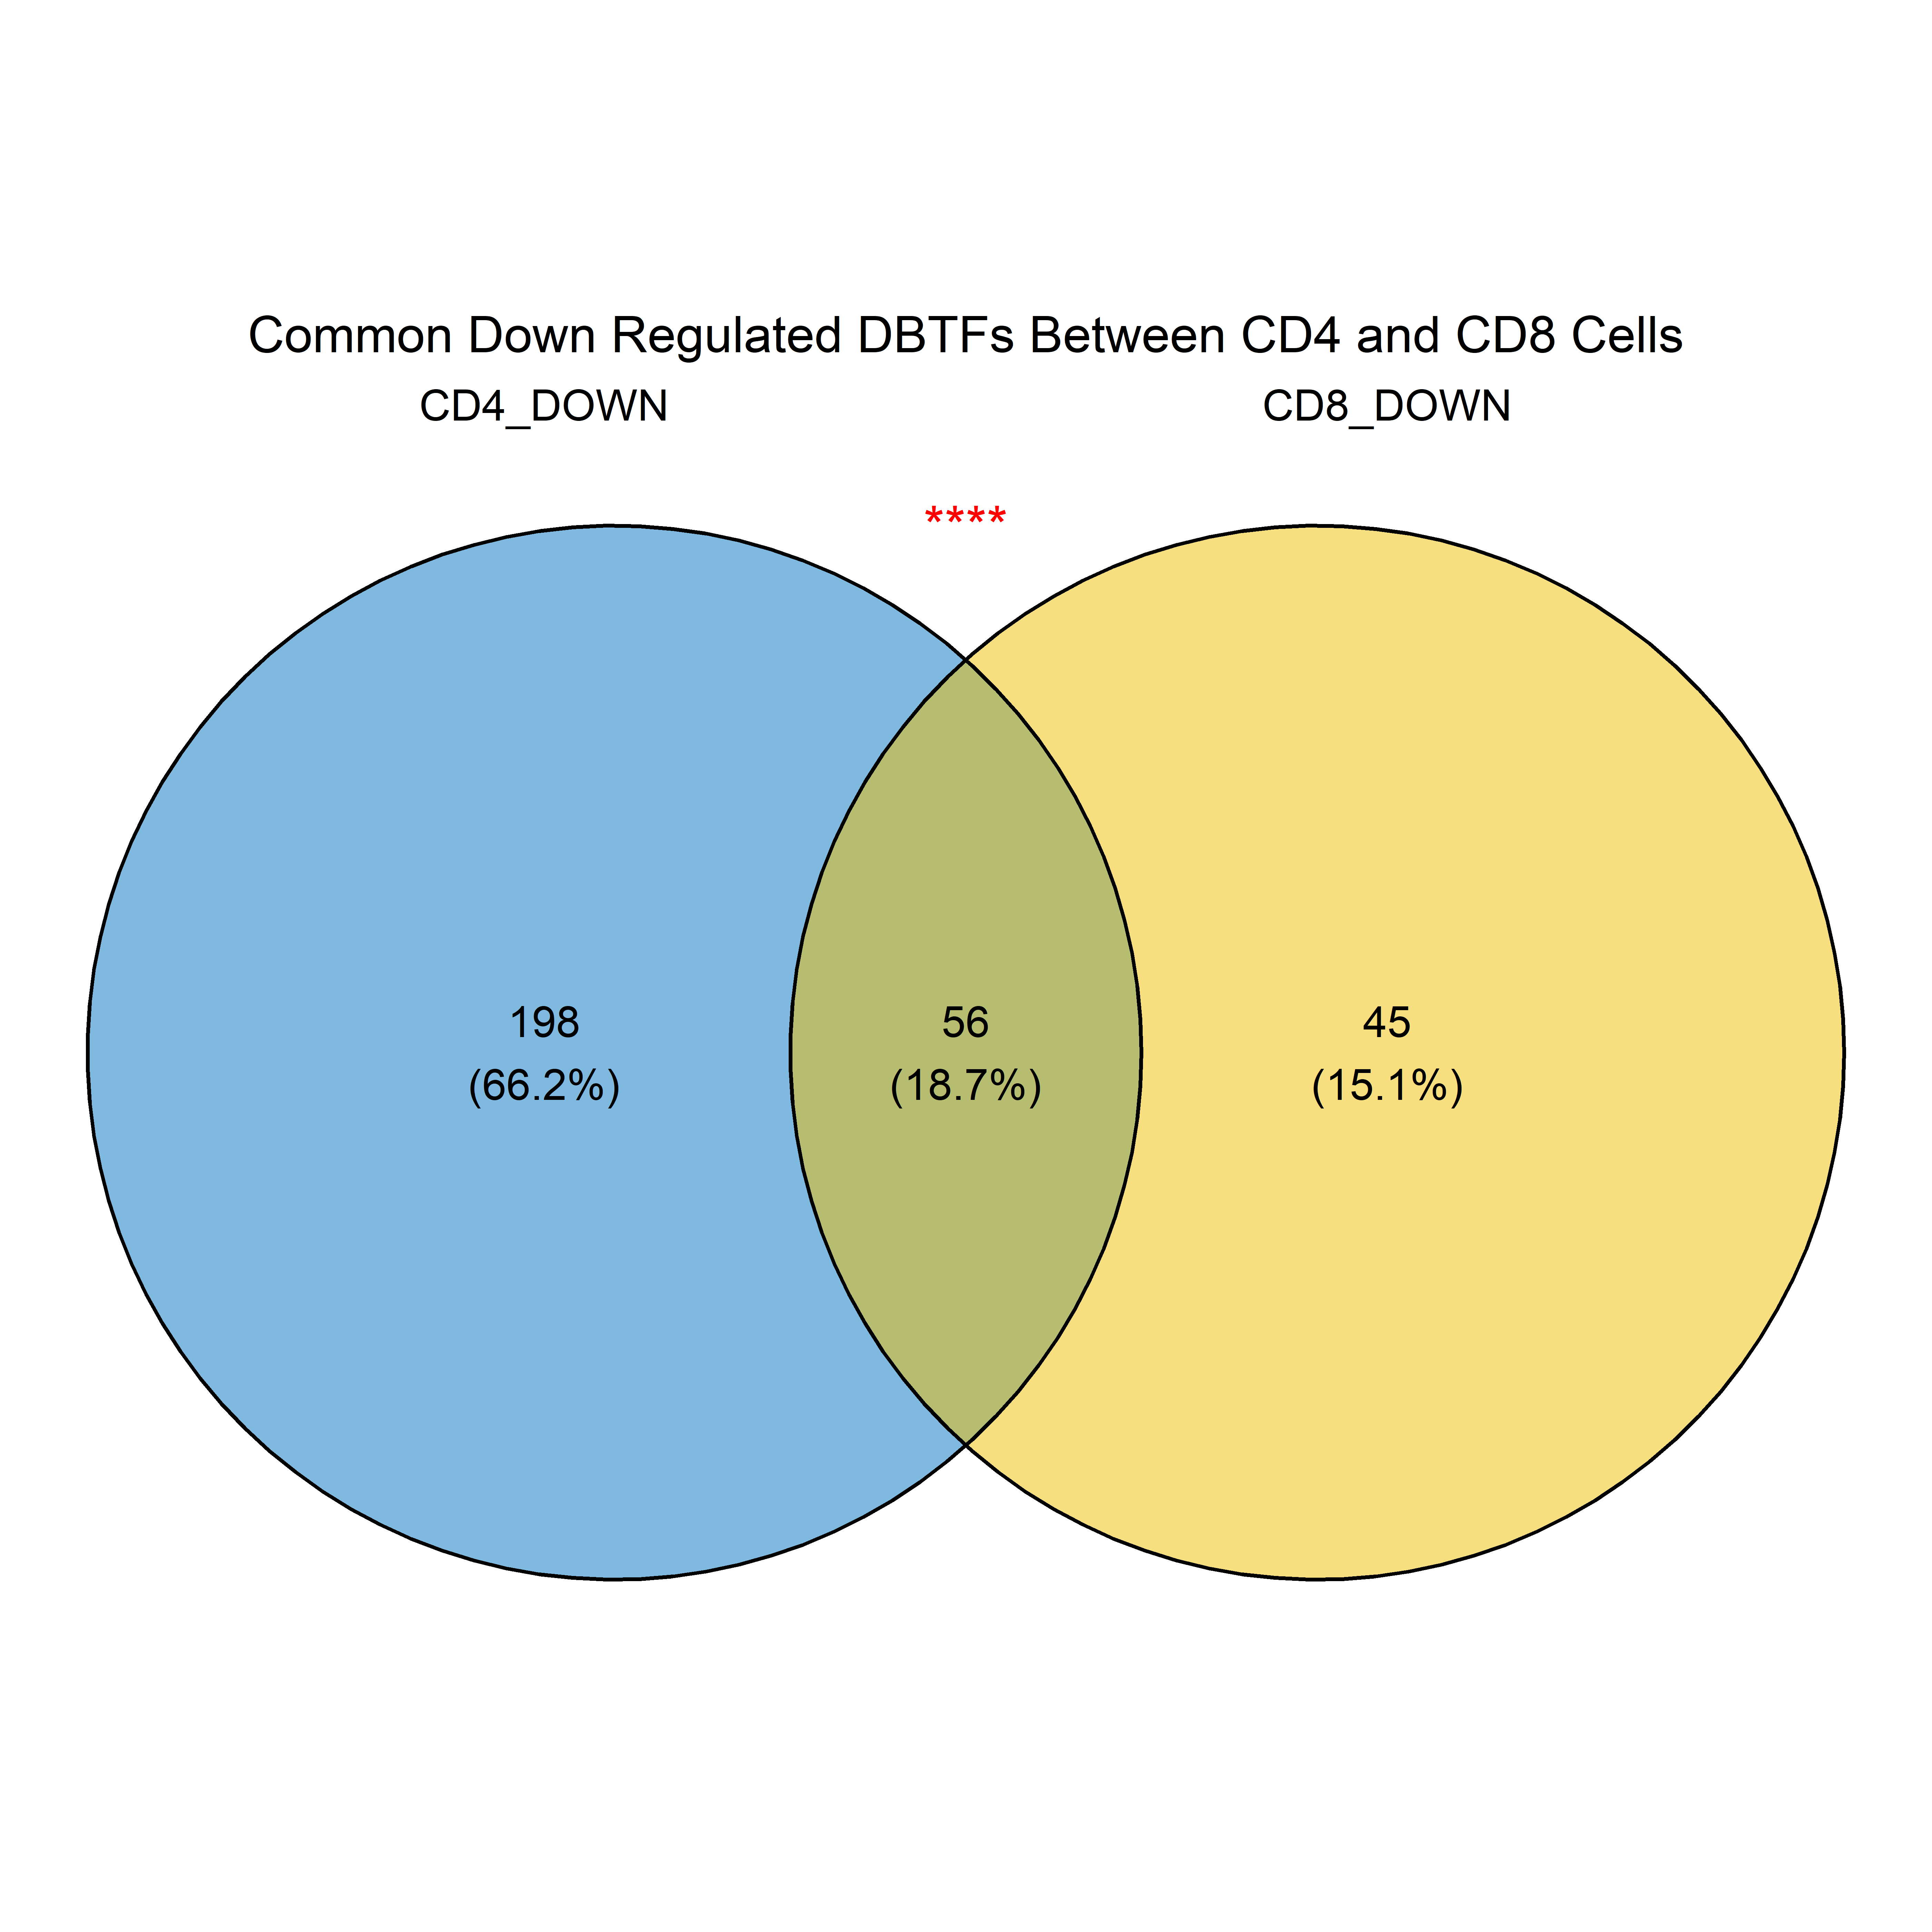Common DBTFs

**B**

**A**

**C**



Figure Legend:

A – A Venn diagram depicting the number of common up-regulated DBTFs in the overlap region. Unique up-regulated DBTFs for CD4 are shown on the left, and unique up-regulated DBTFs for CD8 are shown on the right. An asterisk (*) indicates the statistical significance of the overlap, calculated using a hypergeometric test, with more asterisks indicating a higher level of significance. The p-value for this overlap is 0.

B – A Venn diagram depicting the number of common down-regulated DBTFs in the overlap region. Unique down-regulated DBTFs for CD4 are shown on the left, and unique down-regulated DBTFs for CD8 are shown on the right. An asterisk (*) indicates the statistical significance of the overlap, calculated using a hypergeometric test, with more asterisks indicating a higher level of significance. The p-value for this overlap is 0.

C – A heatmap comparing the logFC values of common DBTFs between CD4 and CD8 experiments. Each row represents a gene associated with DARs. Darker red cells indicate a higher degree of up-regulation, and darker blue cells represent a greater extent of down-regulation of DARs.

**Summary**

**Open Chromatin Analysis:**

1. At a global scale, no significant differences were observed between poor and good responders in either CD8 or CD4 cells.
2. However, differential expression analysis identified significant sites in both CD4 and CD8 cells between the two groups.
3. Further investigation explored the enriched pathways through GSEA.

**Transcription Factor Binding Sites Analysis:**

1. Differentially functional transcription factors (with more bound sites) were identified in both poor and good responders across CD8 and CD4 cells.
2. The signal strength of differential TF binding sites was more pronounced in CD8 cells compared to CD4 cells.

**Overlap Analysis:**

A straightforward overlap analysis revealed statistically enriched, commonly regulated gene sets between CD4 and CD8 cells.

# References

1. Andrews, S. (2010). FastQC: A Quality Control Tool for High Throughput Sequence Data. [Online] Available at: http://www.bioinformatics.babraham.ac.uk/projects/fastqc/
2. Bolger, A. M., Lohse, M., & Usadel, B. (2014). Trimmomatic: a flexible trimmer for Illumina sequence data. Bioinformatics, 30(15), 2114-2120. doi:10.1093/bioinformatics/btu170
3. Bushnell, B. (2014). BBMap: A Fast, Accurate, Splice-Aware Aligner. [Online] Available at: https://sourceforge.net/projects/bbmap/
4. Li, H. (2013). Aligning sequence reads, clone sequences and assembly contigs with BWA-MEM. arXiv:1303.3997v2 [q-bio.GN]
5. Ramírez, F., Dündar, F., Diehl, S., Grüning, B. A., & Manke, T. (2014). deepTools: a flexible platform for exploring deep-sequencing data. Nucleic Acids Research, 42(W1), W187-W191. doi:10.1093/nar/gku365
6. Zhang, Y., Liu, T., Meyer, C. A., Eeckhoute, J., Johnson, D. S., Bernstein, B. E., ... & Liu, X. S. (2008). Model-based analysis of ChIP-Seq (MACS). Genome Biology, 9(9), R137. doi:10.1186/gb-2008-9-9-r137
7. Bentsen, M., Goymann, P., Schultheis, H., Klee, K., Petrova, A., Wiegandt, R., ... & Theis, F. J. (2020). ATAC-seq footprinting unravels kinetics of transcription factor binding during zygotic genome activation. Nature Communications, 11(1), 4267. doi:10.1038/s41467-020-18035-1
8. Rauluseviciute I, Riudavets-Puig R, Blanc-Mathieu R, Castro-Mondragon JA, Ferenc K, Kumar V, Lemma RB, Lucas J, Chèneby J, Baranasic D, Khan A, Fornes O, Gundersen S, Johansen M, Hovig E, Lenhard B, Sandelin A, Wasserman WW, Parcy F, Mathelier A **JASPAR 2024: 20th anniversary of the open-access database of transcription factor binding profiles** *Nucleic Acids Res.* in_press; doi: 10.1093/nar/gkad1059
9. Stark R and Brown G (2011). DiffBind: differential binding analysis of ChIP-Seq peak data. Bioconductor http://bioconductor.org/packages/release/bioc/vignettes/DiffBind/inst/doc/DiffBind.pdfRoss-Innes, C. S., Stark, R., Teschendorff, A. E., Holmes, K. A., Ali, H. R., Dunning, M. J.,Brown, G. D., Gojis, O., Ellis, I. O., Green, A. R., Ali, S., Chin, S.-F., Palmieri, C., Caldas, C., and Carroll, J. S. (2012). Differential oestrogen receptor binding is associated with clinical outcome in breast cancer. Nature 481, 389-393.
10. G. Korotkevich, V. Sukhov, A. Sergushichev. Fast gene set enrichment analysis. bioRxiv (2019), doi:10.1101/060012
11. Twelve years of SAMtools and BCFtools

Petr Danecek, James K Bonfield, Jennifer Liddle, John Marshall, Valeriu Ohan, Martin O Pollard, Andrew Whitwham, Thomas Keane, Shane A McCarthy, Robert M Davies, Heng Li

GigaScience, Volume 10, Issue 2, February 2021, giab008, https://doi.org/10.1093/gigascience/giab008

1. ImmPort, toward repurposing of open access immunological assay data for translational and clinical research. Bhattacharya S, Dunn P, Thomas CG, Smith B, Schaefer H, Chen J, Hu Z, Zalocusky KA, Shankar RD, Shen-Orr SS, Thomson E, Wiser J, Butte AJ. Sci Data. 2018 Feb 27;5:180015. https://doi.org/10.1038/sdata.2018.15
2. Cory Y McLean, Dave Bristor, Michael Hiller, Shoa L Clarke, Bruce T Schaar, Craig B Lowe, Aaron M Wenger, and Gill Bejerano. "GREAT improves functional interpretation of cis-regulatory regions". Nat. Biotechnol. 28(5):495-501, 2010. PMID 20436461
3. Yosuke Tanigawa, Ethan S Dyer, Gill Bejerano. "WhichTF is functionally important in your open chromatin data?" *PLoS Comput Biol*. 2022 Aug 30;**18**(8):e1010378, 2022. PMID 36040971